УДК 625.88

EMBROIDERED PAVING IN THE ARCHITECTURAL ENVIRONMENT OF THE CITY OF ODESA

ВИШИВАНКОВА БРУКІВКА В АРХІТЕКТУРНОМУ СЕРЕДОВИЩІ МІСТА ОДЕСИ

V. V. Dumanska, Ph.D. in Engineering, Associate Professor D. O. Krantovska, higher education student (Odesa State Academy of Civil Engineering and Architecture, Odesa), S. V. Kravchuk, higher education student (Lviv Polytechnic National University)

В. В. Думанська, к.т.н., доцент, Д. О. Крантовська, студентка (Одеська державна академія будівництва та архітектури, м. Одеса), С. В. Кравчук (Національний університет «Львівська політехніка»)

This paper explores the concept of using embroidered paving patterns in urban spaces, particularly in Odesa, as a symbolic integration of Ukrainian tradition and modernity to express national identity. This decorative paving transforms ordinary urban surfaces into a cultural symbol that unites the city’s historical architecture and fosters national unity. This approach turns the architectural space into a visual language of Ukrainian culture, carving history into stone.

У цій роботі досліджується концепція використання орнаментованої бруківки у міському просторі, зокрема в Одесі, як символічного поєднання українських традицій і сучасності для вираження національної ідентичності. Таке декоративне мощення перетворює звичайні міські поверхні на культурний символ, який об’єднує історичну архітектуру міста та сприяє національній єдності. Цей підхід перетворює архітектурний простір на своєрідну візуальну мову української культури, увічнюючи історію в камені.

Paving with embroidered patterns in the urban space is a symbolic combination of tradition and modernity, reflecting the national identity of Ukrainian society.
In the architectural environment of Odesa, this idea takes on special significance, as the city with its multicultural history-embodies the harmonious coexistence of diverse cultural influences. The embroidered paving becomes a visual code of Ukrainian authenticity, integrated into the space of historical streets and contemporary public areas.
Decorative paving serves not only an aesthetic purpose but also shapes the cultural identity of the environment, creating a sense of national unity.
The traditional embroidery patterns, reproduced in stone, lend the city a unique character, visually connecting the architecture of the past and present. This approach transforms ordinary pavement into an artistic and educational element that evokes pride in national heritage.
An example of such an idea is Ukraine Square in Curitiba (Brazil), where the pavement will feature a Ukrainian embroidery pattern symbolizing the unity of the Ukrainian community abroad.
In Ukraine, similar concepts have already been implemented – for instance, in Kamianets-Podilskyi (Fig. 1) and in Lutsk, in Lviv, in Chernivtsi et al., pedestrian alleys are paved with traditional embroidery motifs that harmoniously blend with the city’s architecture.

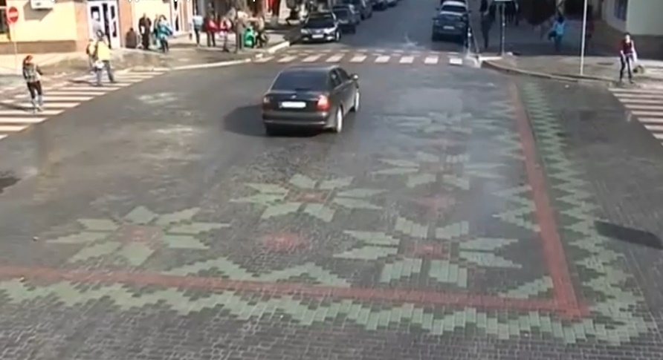
Fig. 1. An example of a Ukrainian ornament laid out with paving stones at one of the central intersections of the city of Kamianets-Podilskyi
(Photo from open sources)

Ukrainian manufacturers of decorative paving also offer complex ornamental compositions for squares, parks, and sidewalks.
For Odesa, this concept could be realized in several ways:
- designing historical pedestrian zones with ornamented fragments;
- creating thematic squares;
- introducing a “Vyshyvanka Route” - a tourist pathway connecting the city’s cultural and architectural landmarks.
By using modern ecological materials and paving technologies, embroidered paving successfully combines beauty, functionality, and durability.
Thus, embroidered paving becomes not only a decorative element of the urban environment but also a cultural symbol of Odesa - a city that unites tradition, creativity, and national uniqueness. It transforms architectural space into a living language of Ukrainian culture, where each ornament becomes part of history carved in stone.

